**3. Do the below programs in arrow functions**

**a. Print odd numbers in an array**

**//Print odd numbers in an array using arrow function**

**var nums = [11,23,24,36,87,95,76,84,39];**

**//creating two empty arrays for odds and evens**

**var odds = [];**

**//var evens = [];**

**//creating a function with one variable i.e., nothing but anonymous function**

**var numbers = nums => {**

**//creating for loop for the given array of numbers**

**for (var i = 0; i < nums.length; i++) {**

**//giving the condition number divided by 2 if it is not equal to zero push odd else push even**

**if ((nums[i] % 2) !== 0) {**

**odds.push(nums[i]);**

**}**

**/*else {**

**evens.push(nums[i]);**

**}*/**

**}**

**};**

**//calling the function**

**numbers(nums);**

**console.log(odds);**

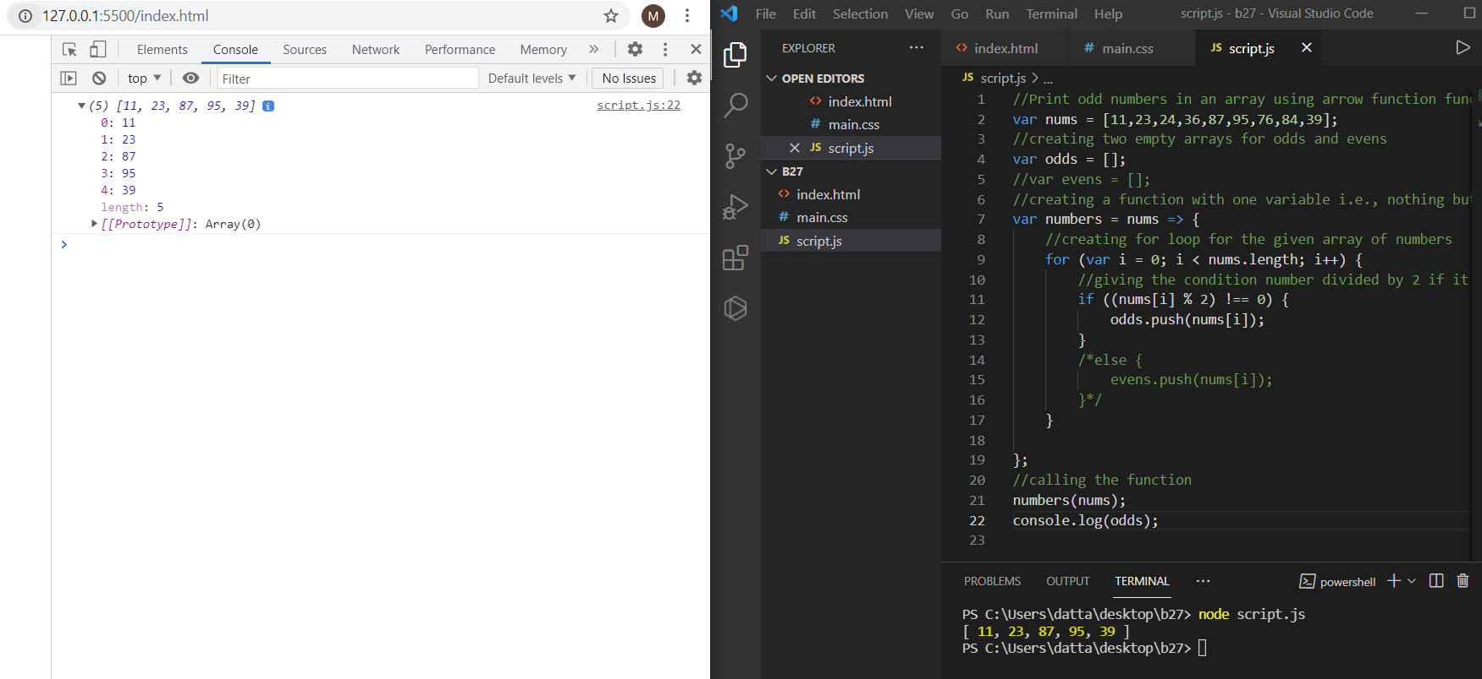

**b. Convert all the strings to title caps in a string array**

**//Convert all the strings to title case in a string array using arrow function**

**// defining the array of strings to**

**var arr = ["zen", "guvi", "fullstack", "javscript", "python"];**

**// creating the variable with name and defining the function in it**

**var TitleCase = () => {**

**// creating the for loop over the array and iterating**

**for (var i = 0; i < arr.length; i++) {**

**//for every iteration convert to title case and printing every string**

**console.log(arr[i][0].toUpperCase() + arr[i].substr(1));**

**}**

**};**

**// calling the function**

**TitleCase();**

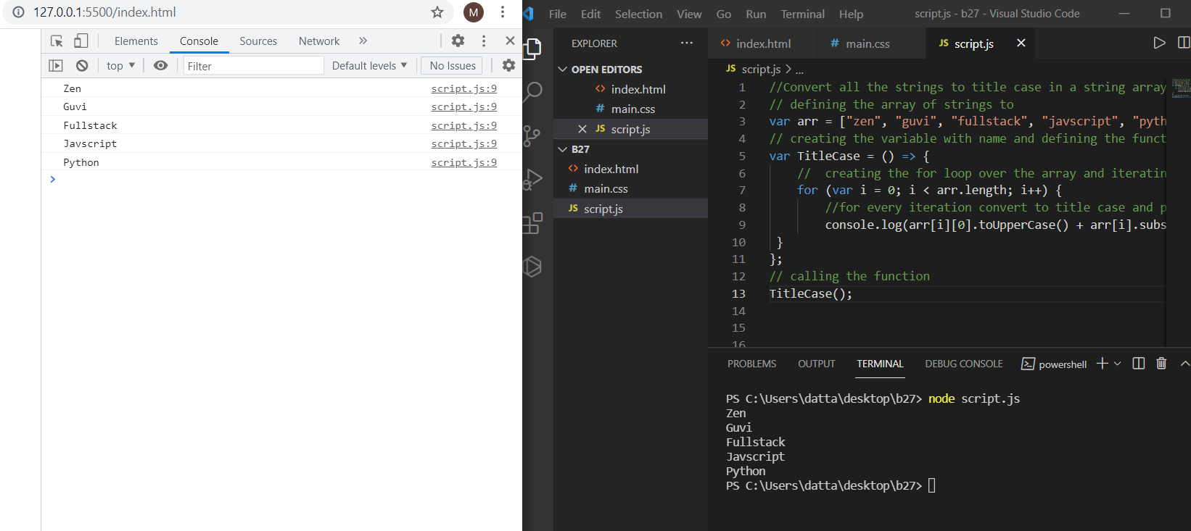

**c. Sum of all numbers in an array**

**//Sum of all numbers in an array using arrow function**

**var nums = [9,15,17,27,43,76,98,45];**

**//creating one variable with sum as 0**

**var sum = 0;**

**//creating a function with one variable i.e., nothing but anonymous function**

**var numbers = nums => {**

**//creating for loop for the given array of numbers to iterate all the numbers**

**for (var i = 0; i < nums.length; i++) {**

**//adding the values for every iteration and storing in sum variable**

**sum +=nums[i];**

**}**

**};**

**//calling the function**

**numbers(nums);**

**console.log(sum);**

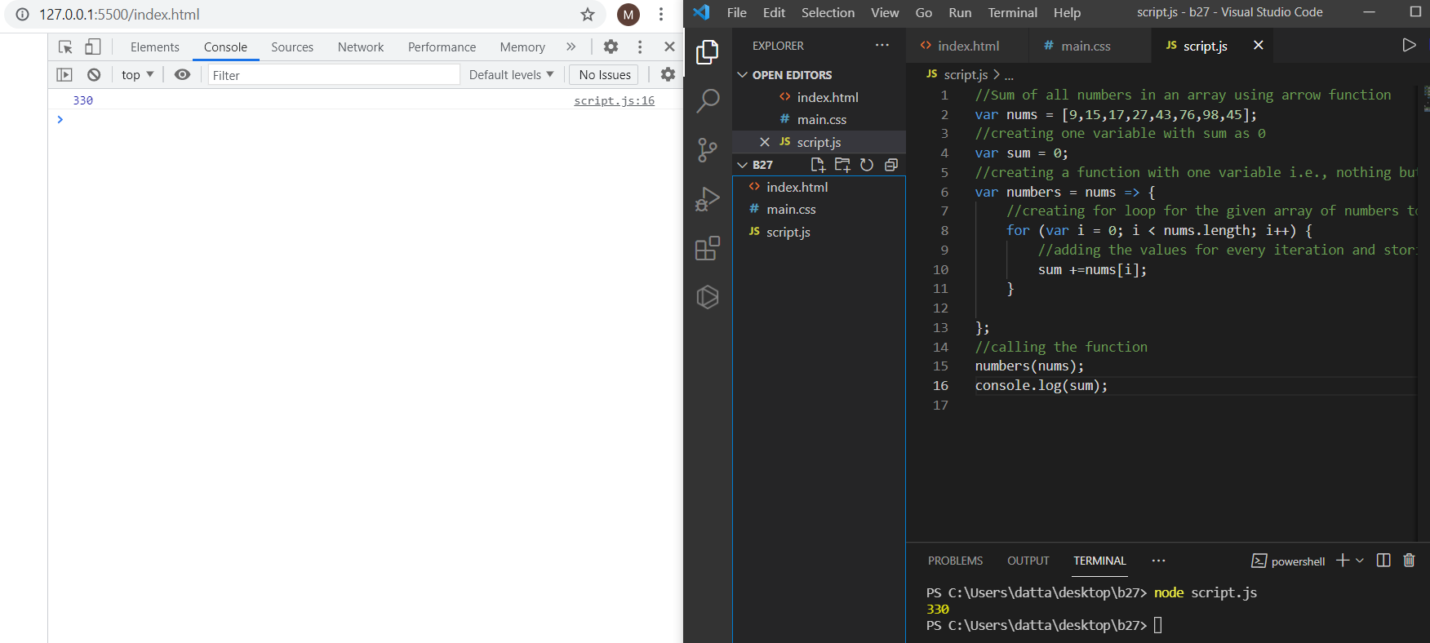

**d. Return all the prime numbers in an array**

**//Return all the prime numbers in an array using arrow function function**

**// creating one array of numbers with variable**

**const newArray = [1, 3, 2, 5, 10, 11, 13, 15, 23, 27, 28, 33, 16, 18];**

**//with one variable we are creating function and doing filter after iteration**

**const myPrimeArray = newArray.filter(num => {**

**//creating for loop for checking array of numbers and iterating over it**

**for (let i = 2; i < num; i++) {**

**//if condition is equal to zero return false otherwise return true**

**if (num % i === 0) return false;**

**}**

**return num !== 1;**

**});**

**// printing the final output in the array**

**console.log(myPrimeArray);**

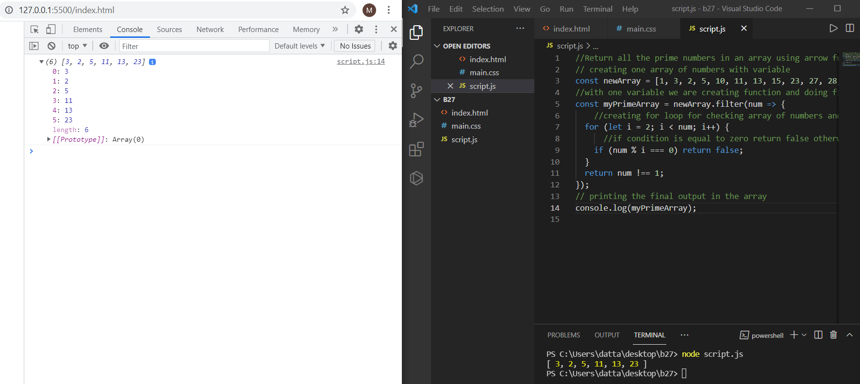

**e. Return all the palindromes in an array**

**//Return all the palindromes in an array using arrow function**

**// defining one array with strings and numbers**

**const arr = ['carecar', 1344, 12321, 'did', 'cannot'];**

**// creating one arrow function for checking the array**

**const isPalindrome = el => {**

**// converting each number or word to string**

**const str = String(el);**

**let i = 0;**

**let j = str.length - 1;**

**// writing while loop for iterating over array**

**while(i < j) {**

**// writing if condition string of i is equal to string og j then if condition executes and return true otherwise return false**

**if(str[i] === str[j]) {**

**i++;**

**j--;**

**}**

**else {**

**return false;**

**}**

**}**

**return true;**

**};**

**// created another arrow function for filtering the array after checking the array**

**const findPalindrome = arr => {**

**return arr.filter(el => isPalindrome(el));**

**};**

**// calling the function**

**console.log(findPalindrome(arr));**

